SmartTech Network Simulation Documentation

Name: Odunuga Fatai Olayinka

- Network Topology Screenshot
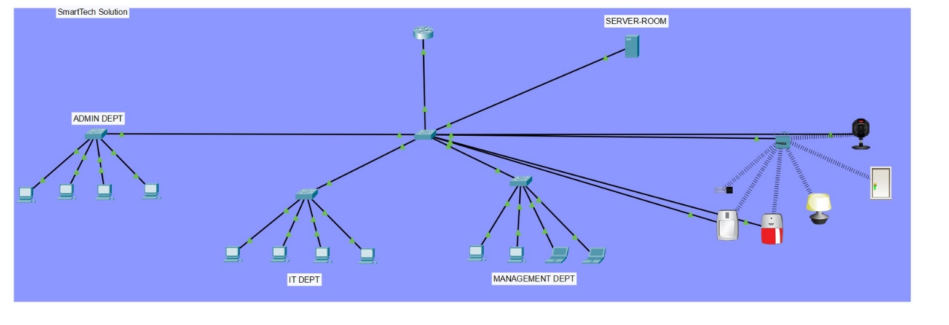

The SmartTech network uses a single-subnet, star topology built around a central multilayer switch. A Cisco router (192.168.10.1) sits at the top as the network's default gateway, connected to the central switch alongside the Server Room (hosting DHCP, DNS, HTTP, FTP, Email, and IoT services on 192.168.10.2).
Three department switches branch off the central switch, each serving a dedicated end-user segment:
- Admin Dept — 4 PCs
- IT Dept — 4 PCs/laptops
- Management Dept — 4 PCs/laptops
A fourth branch connects an IoT switch, linking smart devices (motion detector, smart lock, smart lighting, and an IP camera) both directly via cable and wirelessly through a Home Gateway, enabling automation such as motion-triggered lighting.
All departments and the server share the same 192.168.10.0/24 address space, with the router providing inter-segment routing and the server providing DHCP, name resolution, and application services to every connected device — meaning the network is logically flat (no VLAN segmentation) despite the physical department separation.

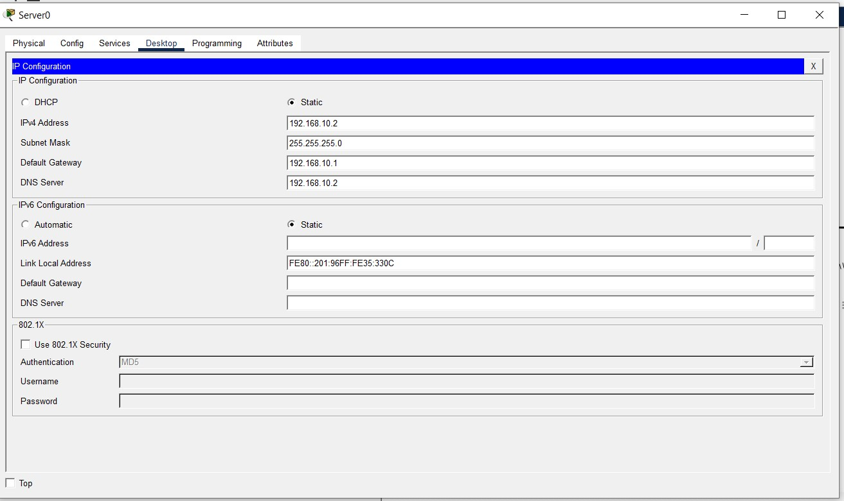
- IP Addressing Table
Devices | Role | IP Address | Subnet Mask | Default Gateway | DNS server | Assignment
Router | Gateway / Router | 192.168.10.1 | 255.255.255.0 |  |  | Static
Server | DHCP/DNS/HTTP/FTP/Email/IoT Server | 192.168.10.2 | 255.255.255.0 | 192.168.10.1 | 192.168.10.2 (self) | Static
Admin 1 | Admin Dept PC | 192.168.10.24 | 255.255.255.0 | 192.168.10.1 | 192.168.10.2 | DHCP
IT 3 | IT Dept PC | 192.168.10.17 | 255.255.255.0 | 192.168.10.1 | 192.168.10.2 | DHCP
Management 3 | MGMT Dept PC | 192.168.10.21 | 255.255.255.0 | 192.168.10.1 | 192.168.10.2 | DHCP
Other endpoints (Admin/IT/Mgmt) | Other Depts | 192.168.10.10-69 | 255.255.255.0 | 192.168.10.1 | 192.168.10.2 | DHCP

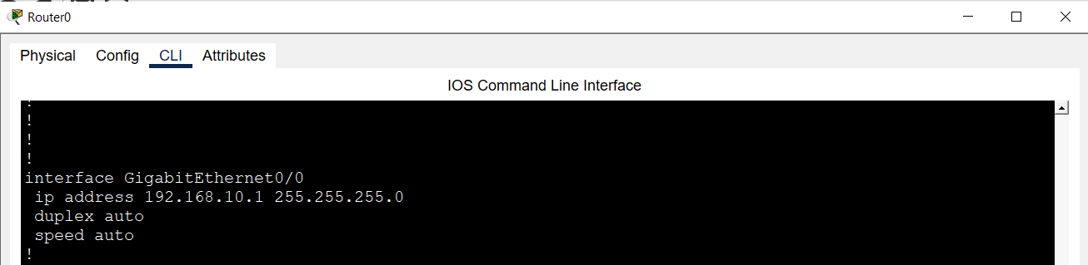

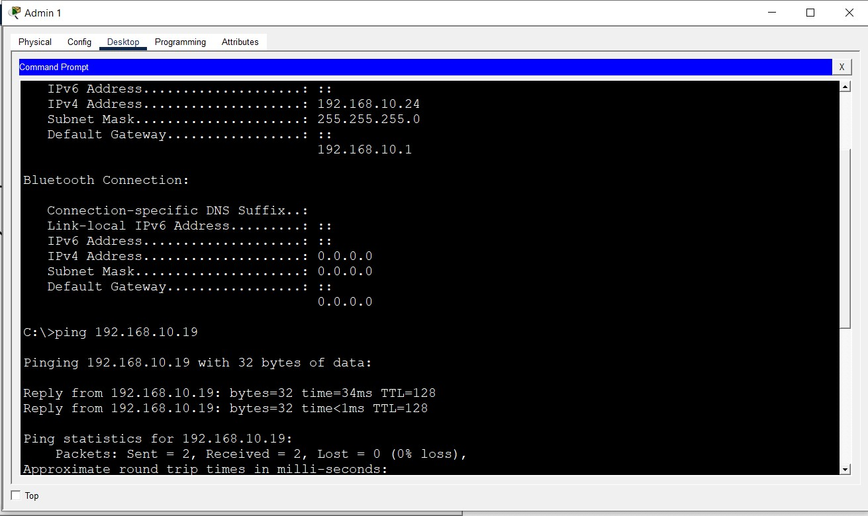

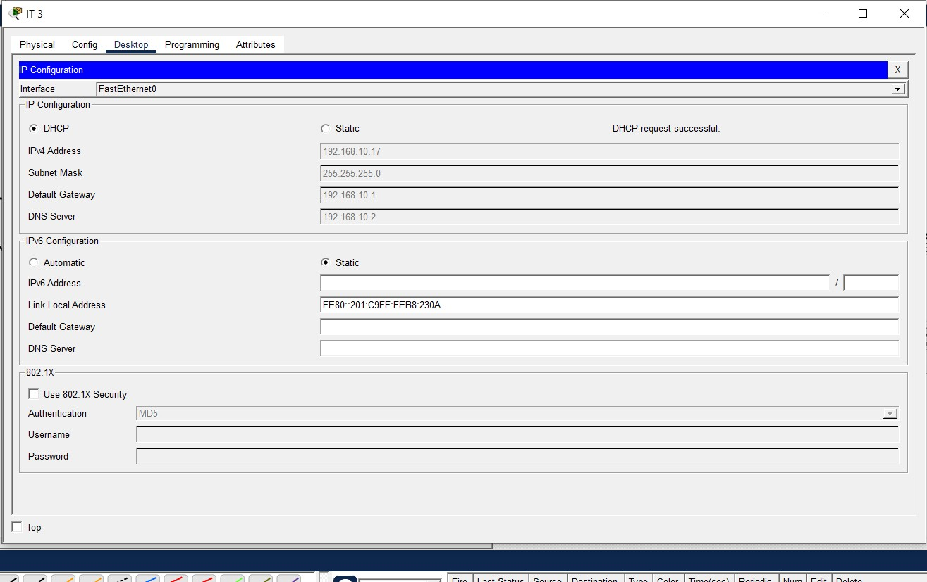

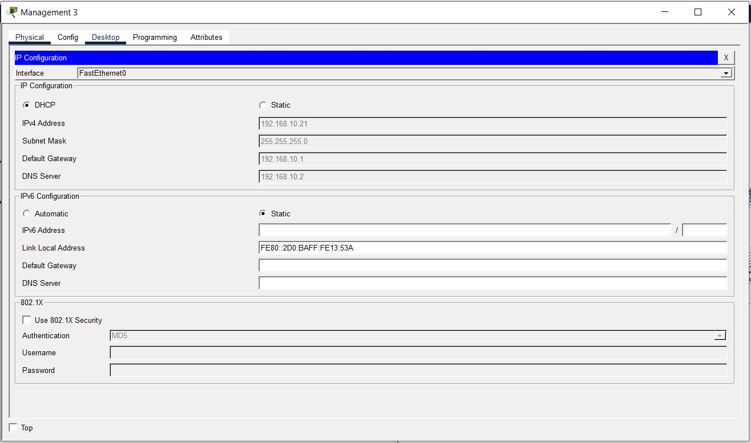
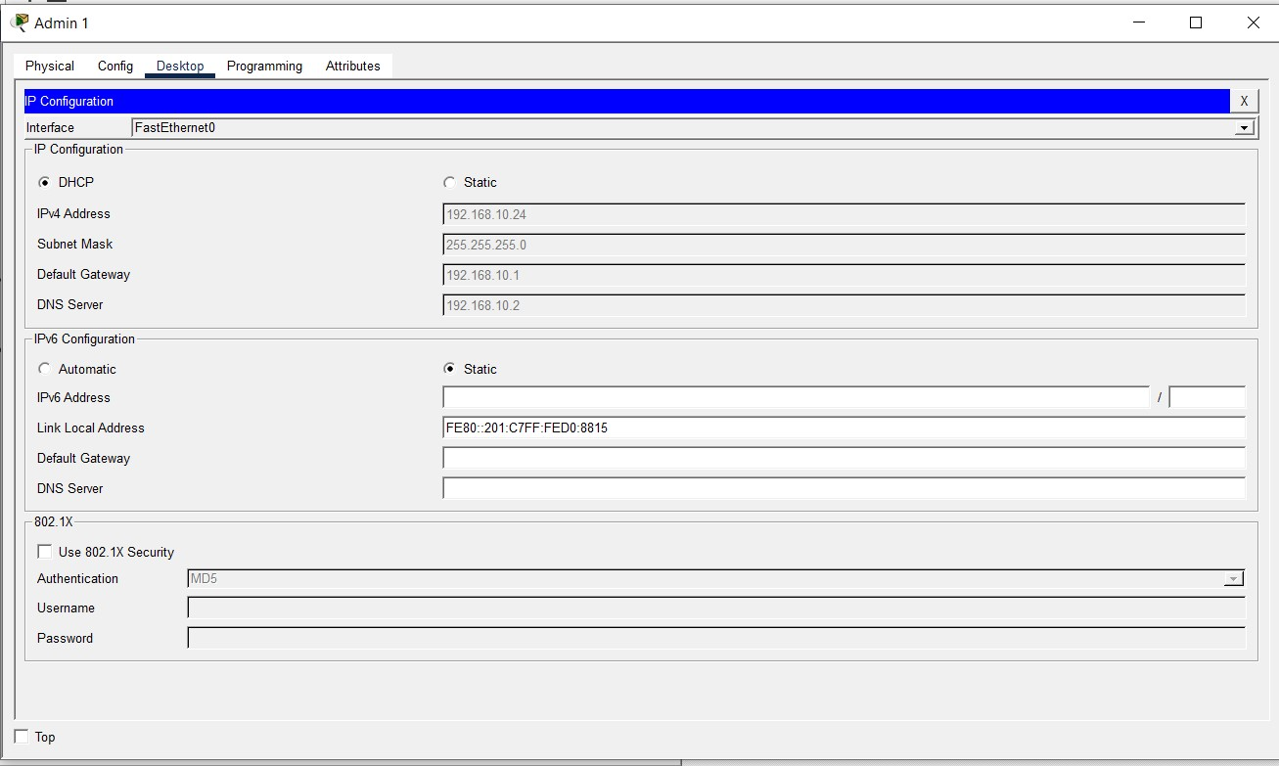

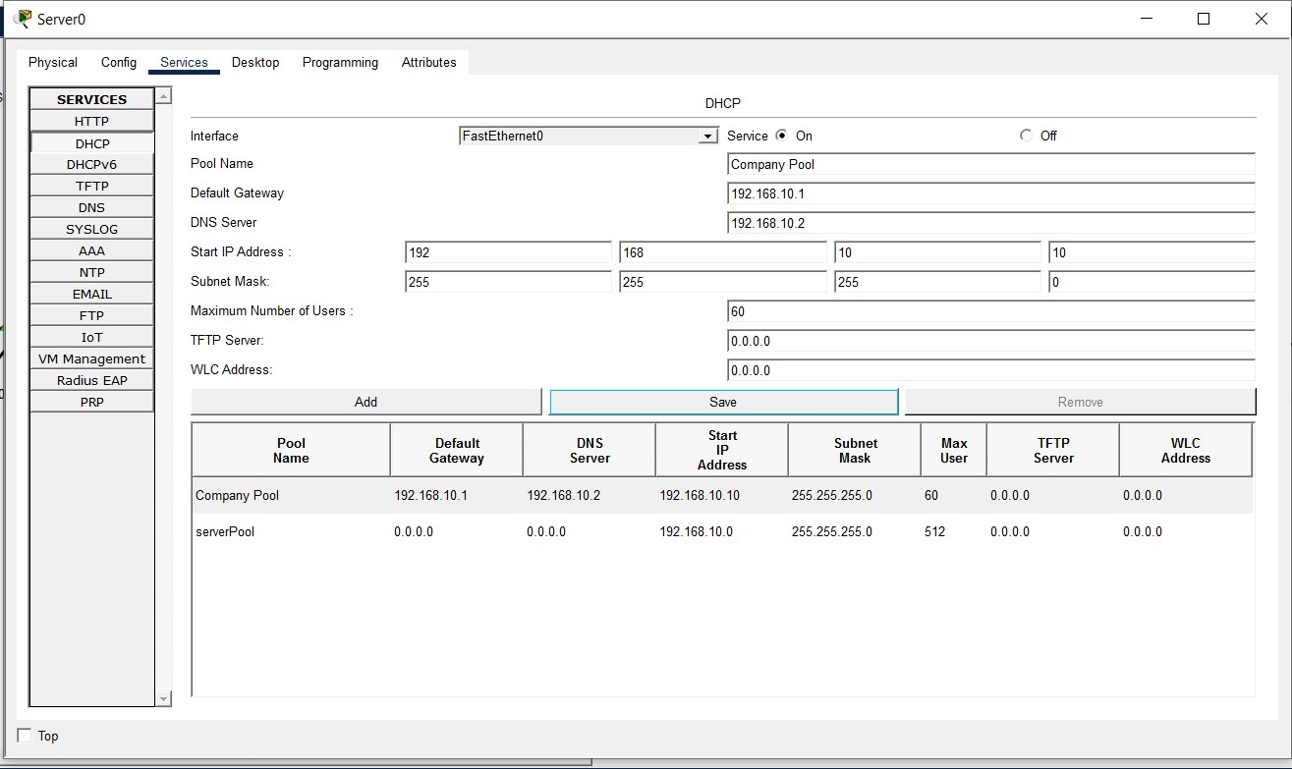
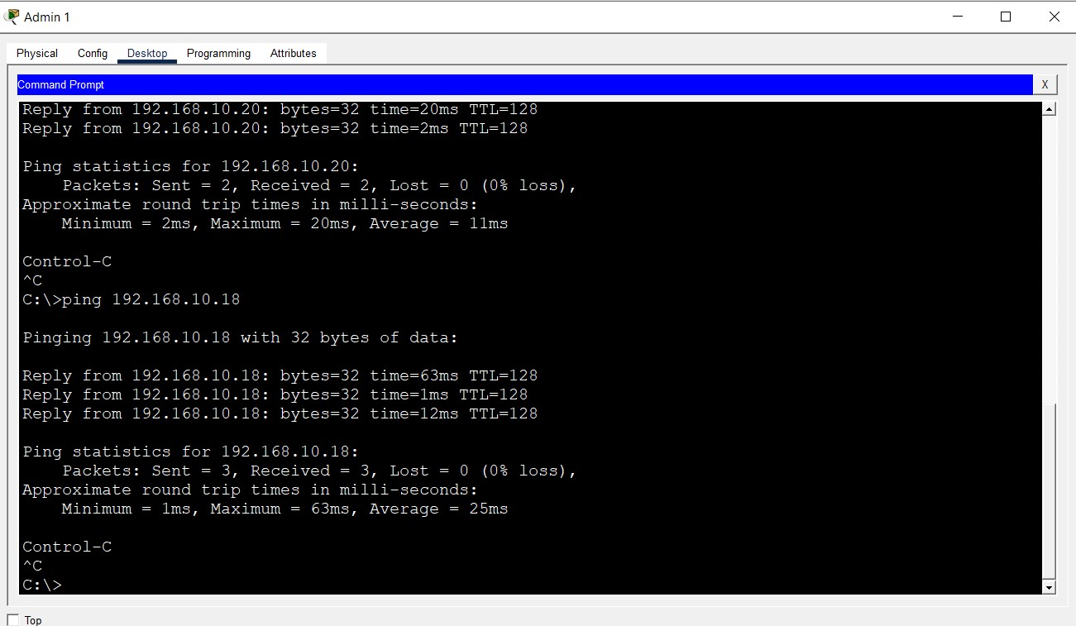

The screenshots above shows the flow of ip addressing and testing, the excerpts explanation goes thus:
a. The server IP was configured (IP: 192.168.10.2, Subnet Mask: 255.255.255.0, Gateway: 192.168.10.1, DNS server: 192.168.10.2)
b. The Router was given an IP address 192.168.10.1 with subnet mask of 255.255.255.0.
c. Admin PCs IP address was checked using ipconfig on the command prompt and it gave us an IP: 192.168.10.24, Subnet: 255.255.255.0 and gateway: 192.168.10.1. Same was replicated on IT and Management PCs, screenshots attached.
d. ping was used to test devices in same dept and different depts. Screenshots attached.

- DHCP CONFIGURATIONS

Configured DHCP Addressing on the server by editing the necessary column above which provided every devices connected to the server with dynamic IP address. Screenshot above.

Management PC taking DHCP IP Address

Admin PC taking DHCP IP Address

IT PC taking DHCP IP Address

4.​ DNS configuration
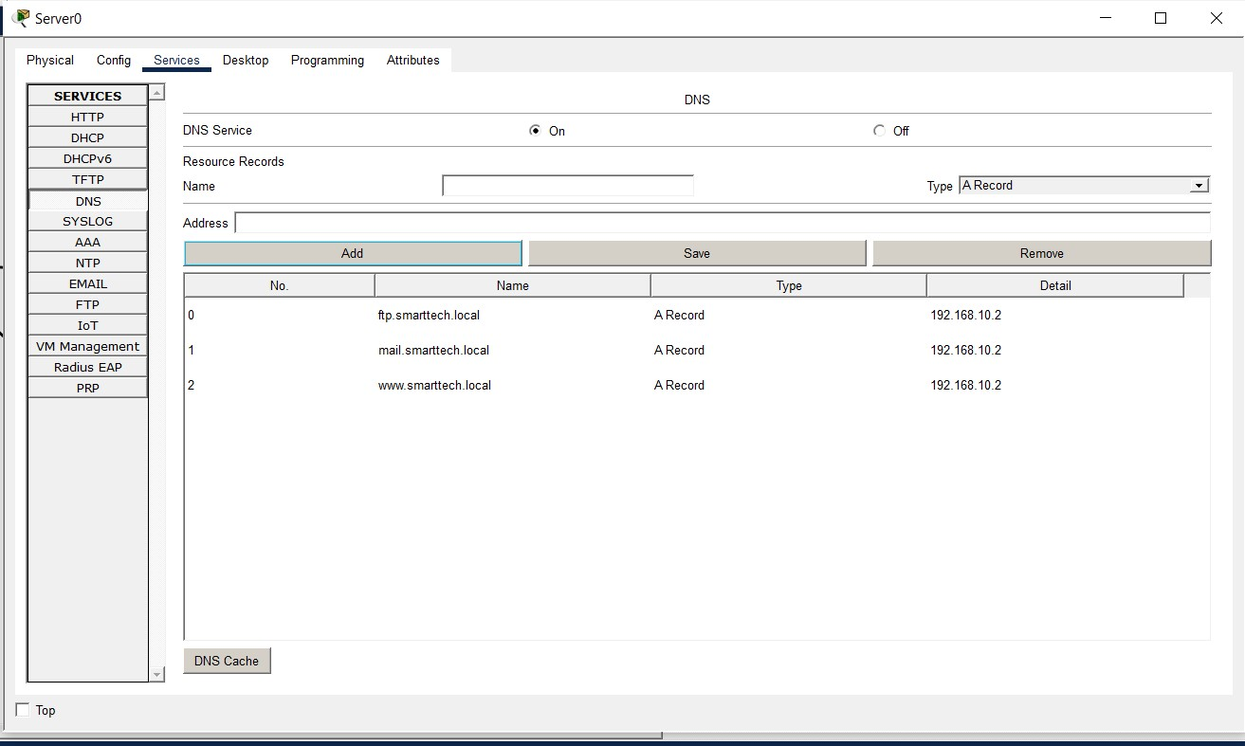
Domain Name Service was configured using the server DNS service. The provided domain names was configured, with A Record type with the server IP as the domain address.
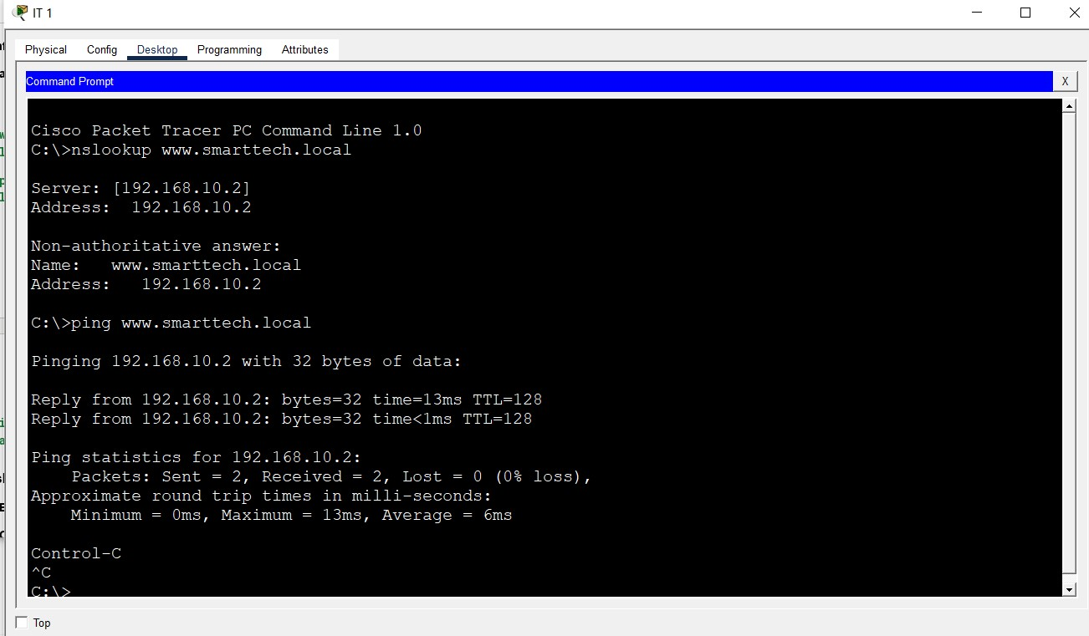
www.smarttech.local was looked up using nslookup and pinged from IT PC to confirm.
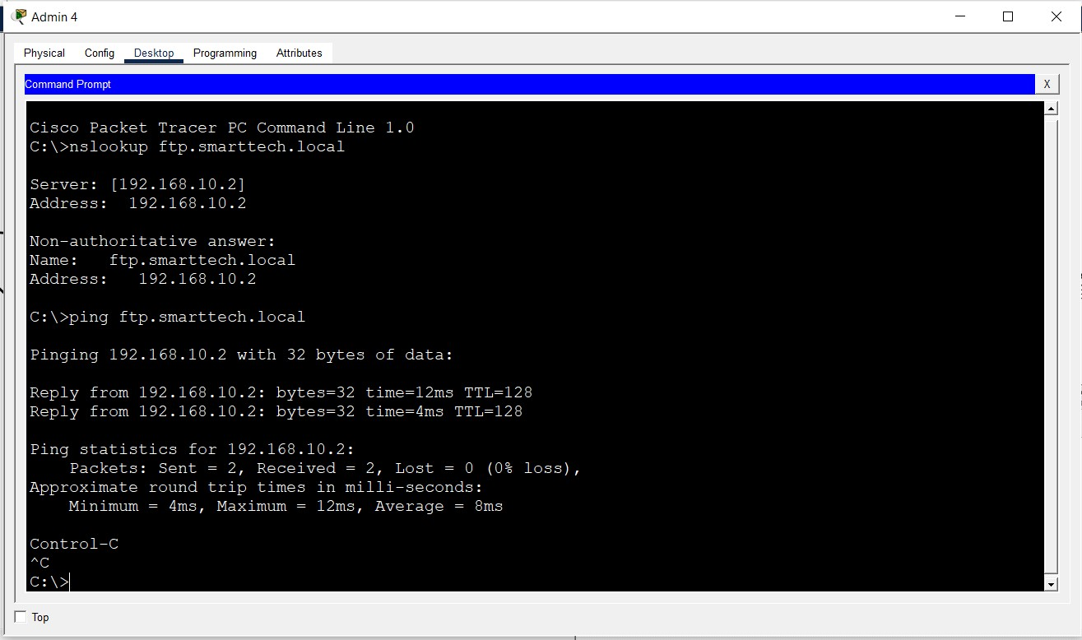
ftp.smarttech.local was looked up using nslookup and pinged from IT PC to confirm.
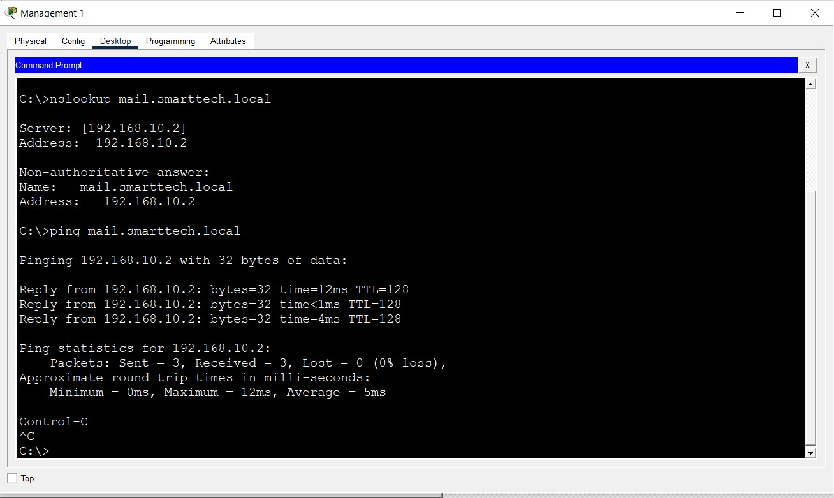
mail.smarttech.local was looked up using nslookup and pinged from IT PC to confirm.

5.​ HTTP configuration
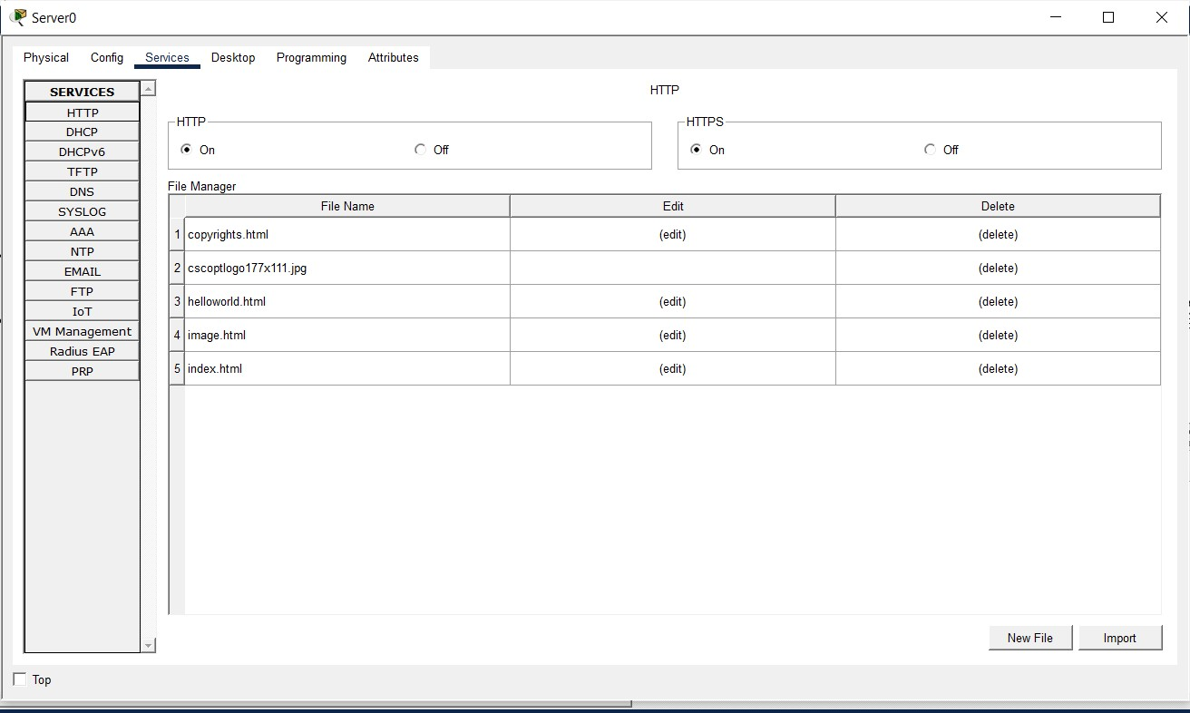
Navigated to the Server HTTP service and turned it on for HTTP access.

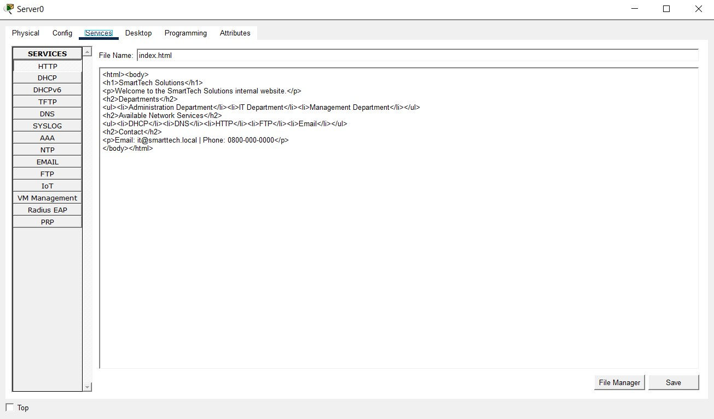
Edited the index,html file of the Server HTTP service and populated it with an HTML welcome messages for the Company and its departments.
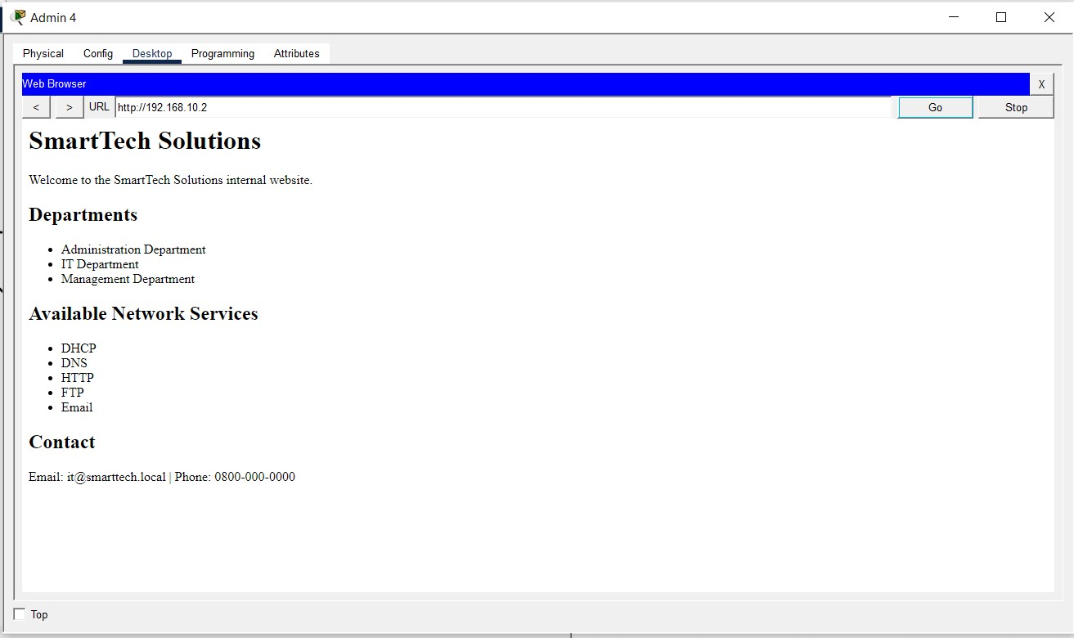
Navigated to a PC Web Browser to test the HTTP service using the server’s IP address.

6.​ FTP configuration
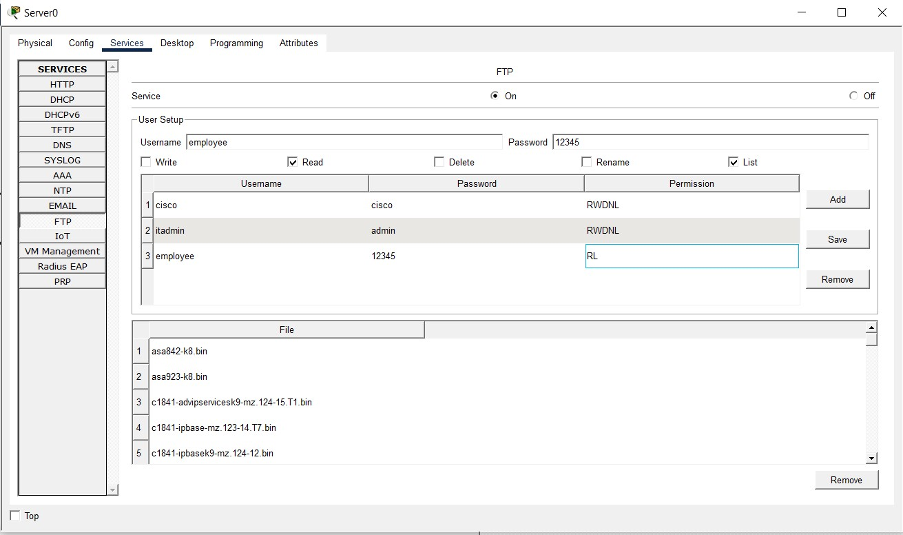
Navigated to the FTP service on the server, turned it on, created two users with password. I also implement RBAC with the Admin being able to RWDL, while employee should only RL.

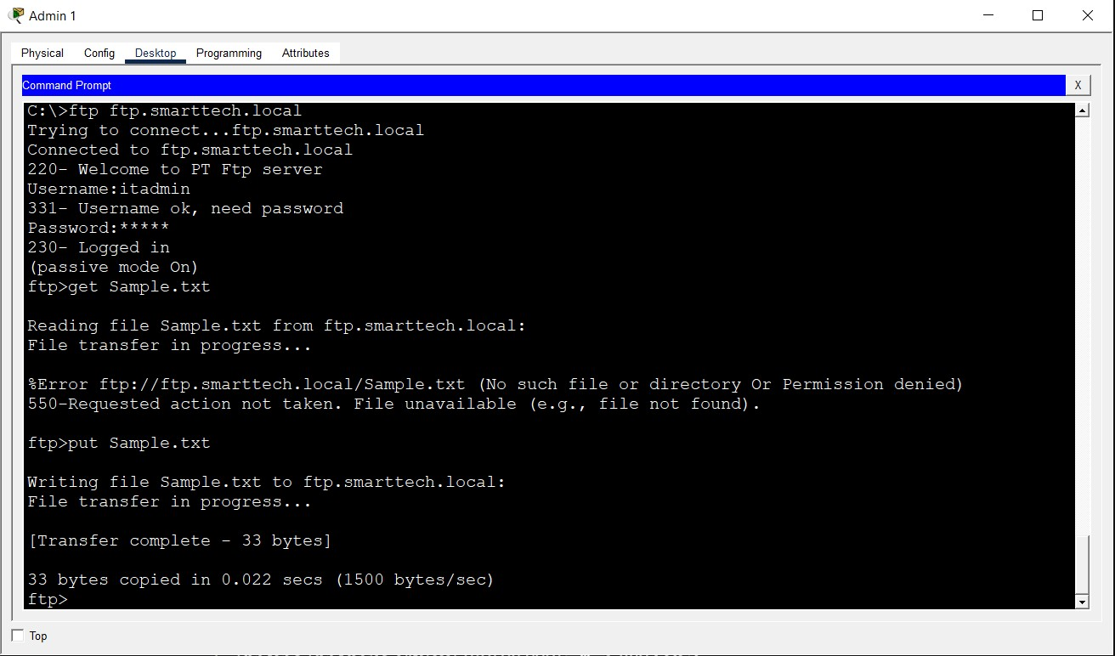
Logged in to the FTP server using an Admin credentials and downloaded a sample text from the PC to the server using the get command.

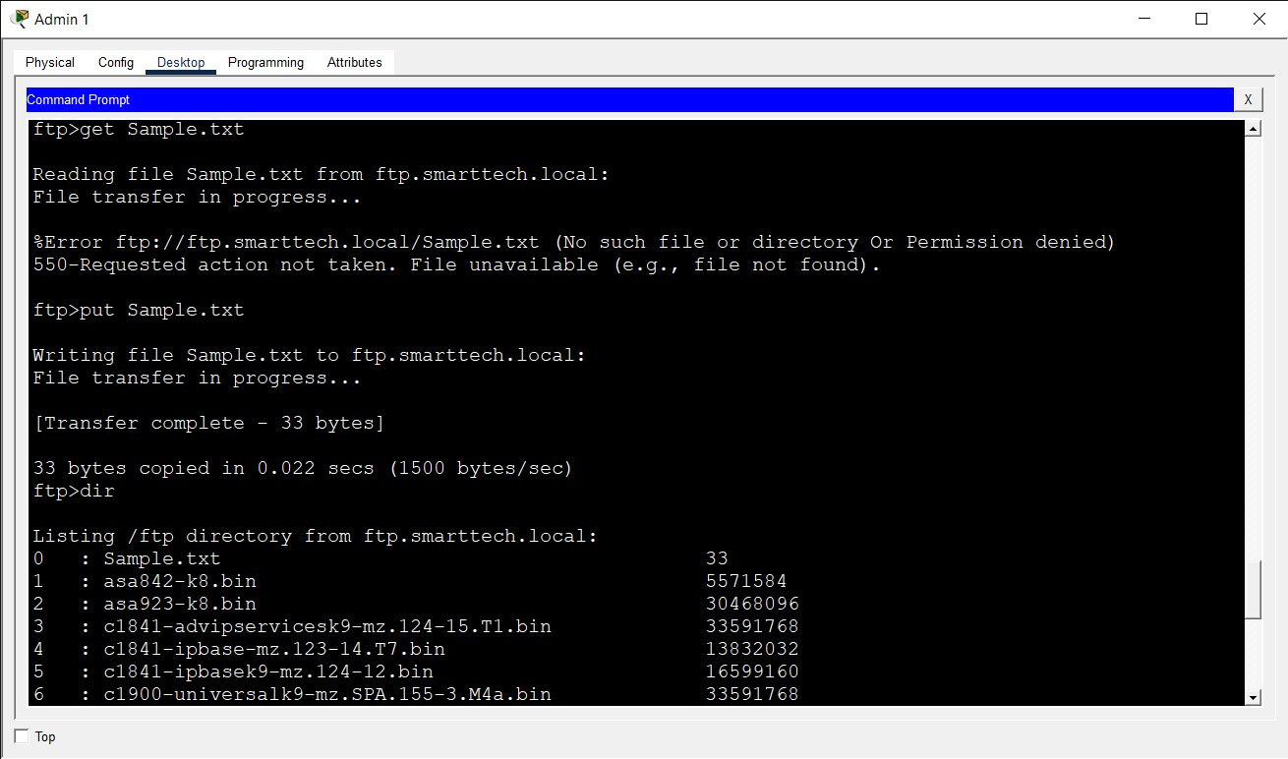
Used the dir command to check if the file is available on the server, which was confirmed.
7.​ Email configuration
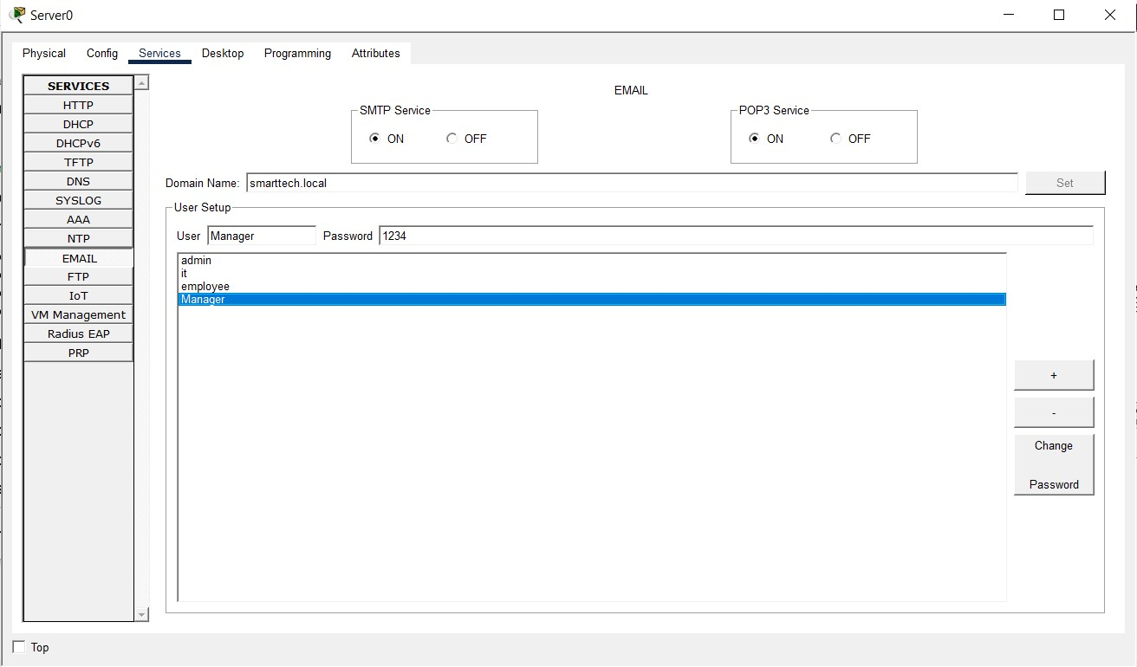
Configured the mail services by turning on mail services on Server Mail services. Consequently registered four accounts with domain name.
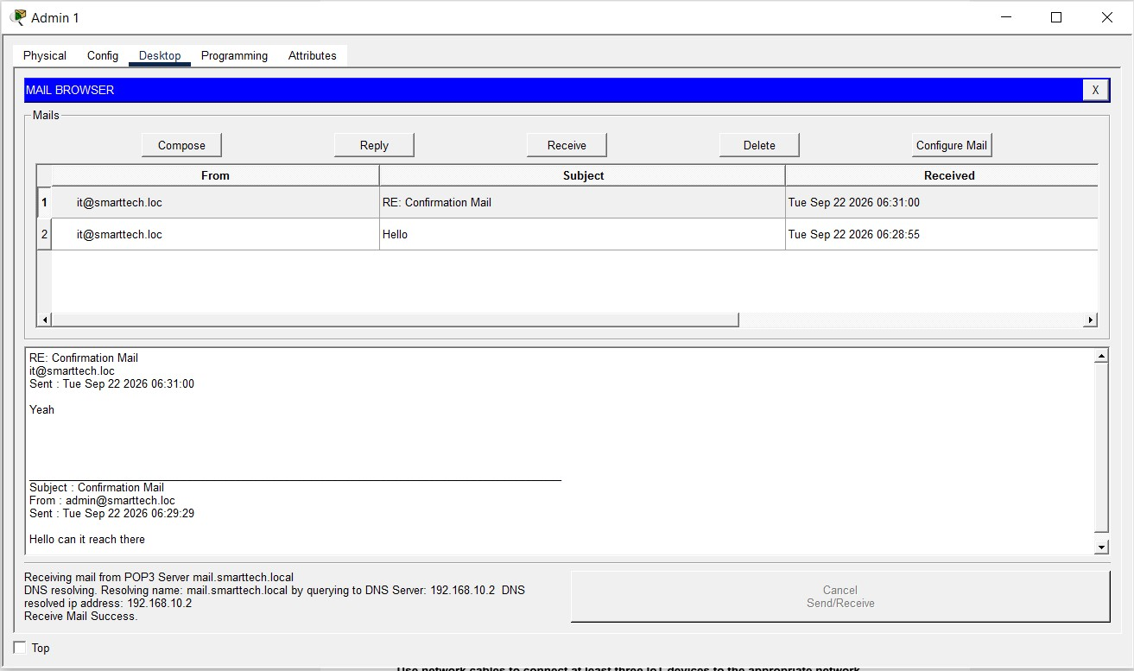
A mail sent and received from it@smarttech.local

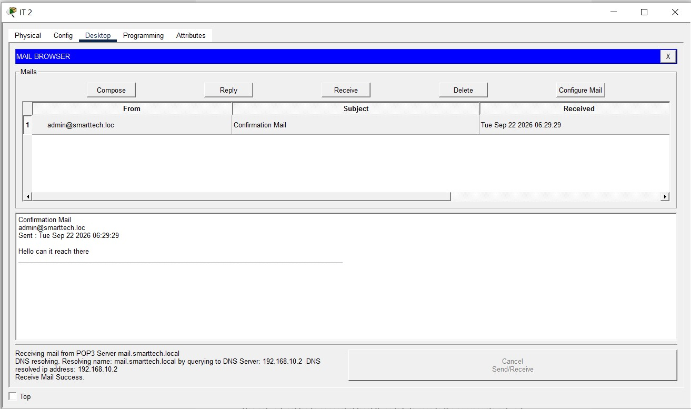
A mail sent and received from admin@smarttech.local

8.​ IoT configuration
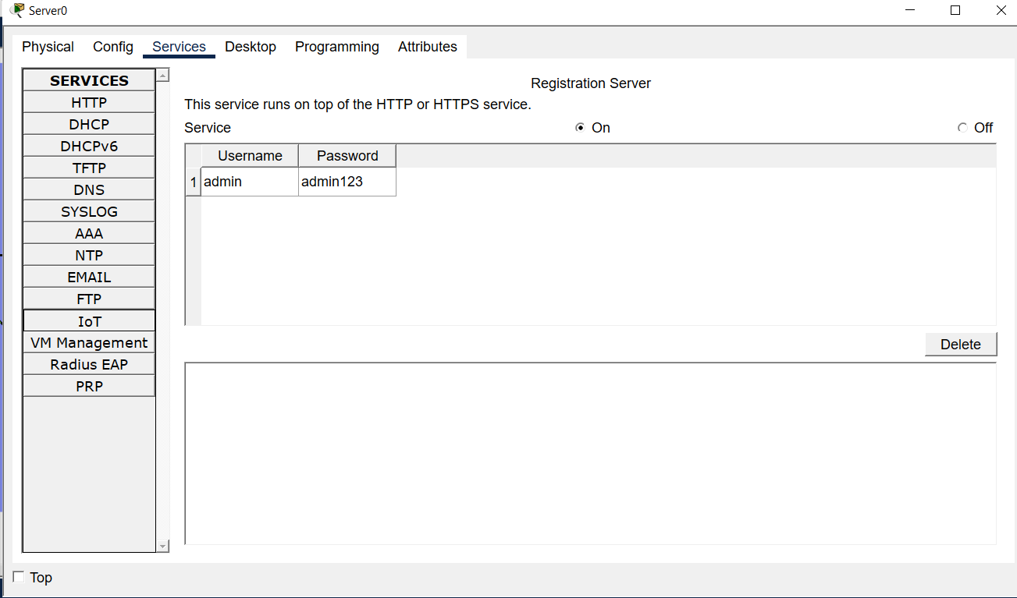
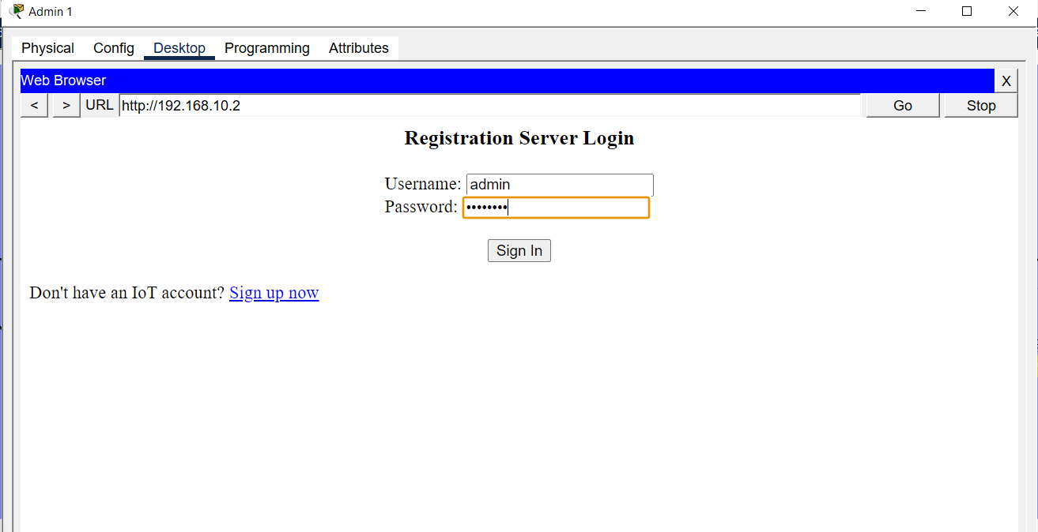
Configured IOT services by turning on IOT services in Server services. Consequently registered an account on a PC web brower with the credentials above.

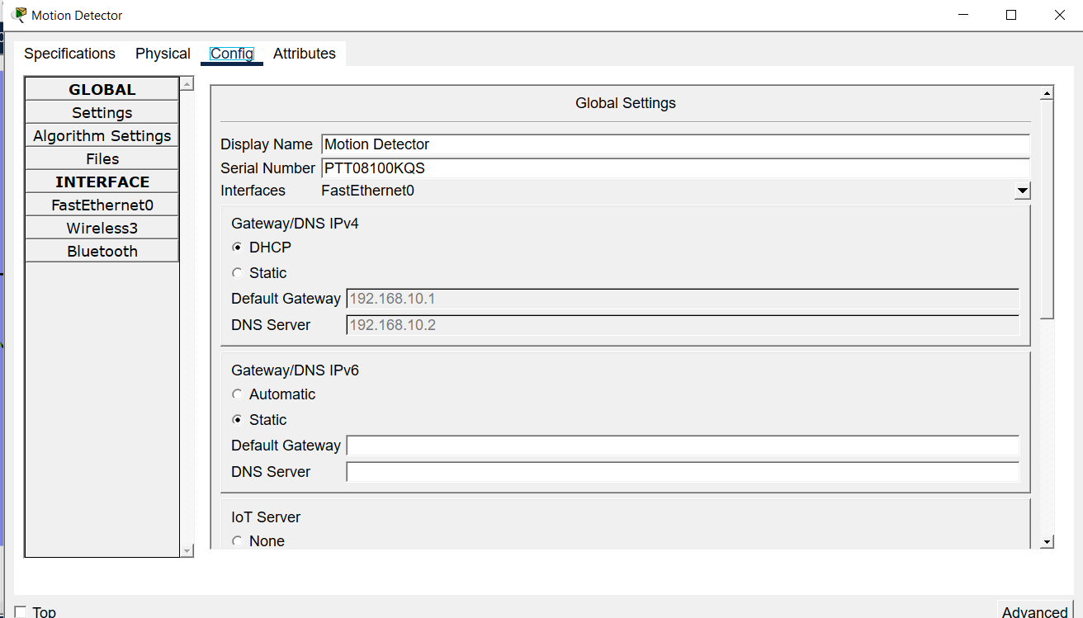
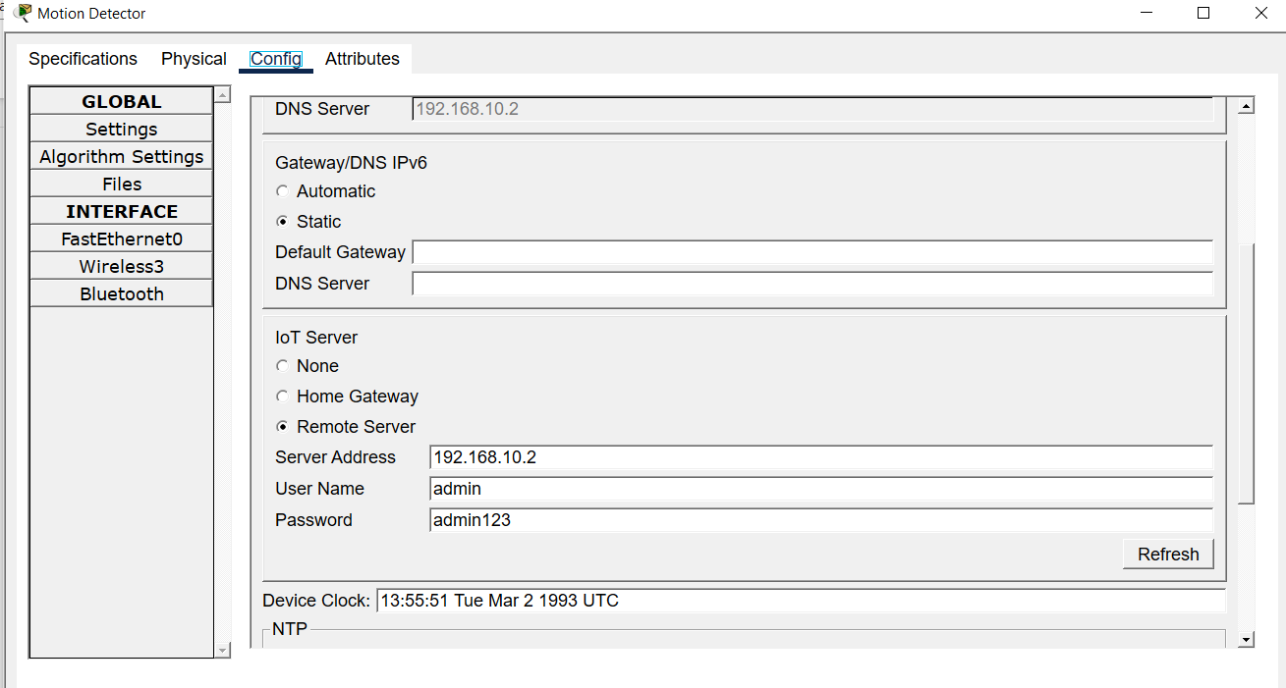
Turned on DHCP on the IOT’s connected directly to the switch and also connected them to the IOT server with the valid credentials. Did same for other IOTs devices connected to the main switch.

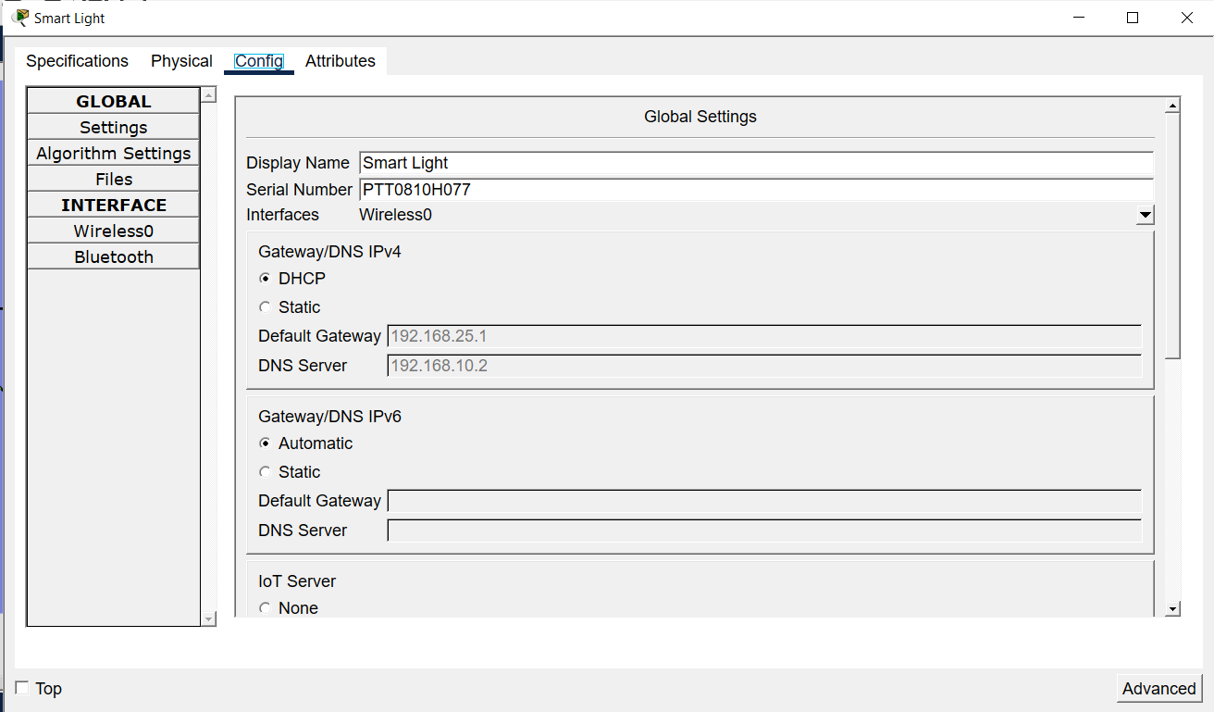
Turned on DHCP on the IOT’s connected to the Home Gateway wirelessly and also connected them to the IOT server with the valid credentials. Did same for other IOTs devices connected to the Home Gateway wirelessly.
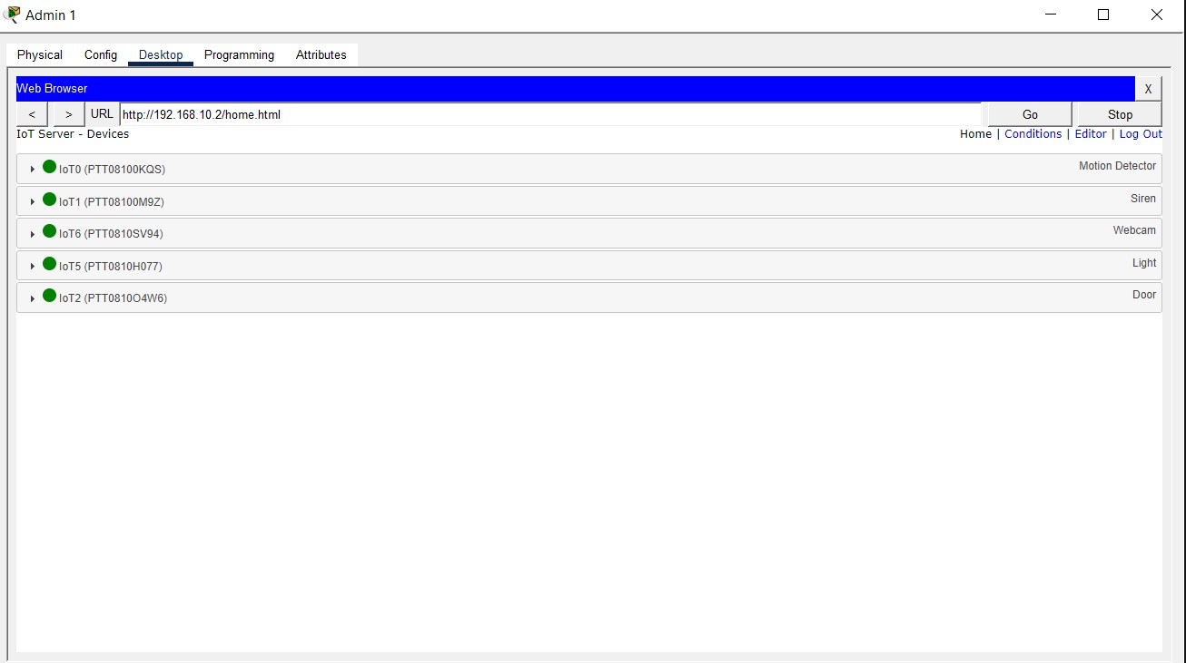
Confirmed via the Web browser that all IOT devices are registered.
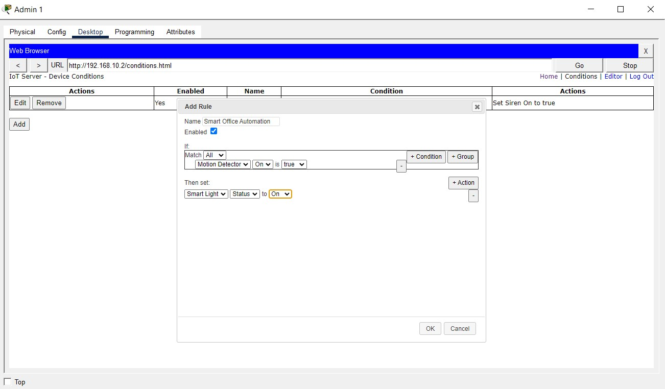
Create an automation in the office for the Motion detector. Whenever the motion detector is triggered (achieved by holding down alt + click the Motion detector) the light comes on. Screenshot of result is attached below.

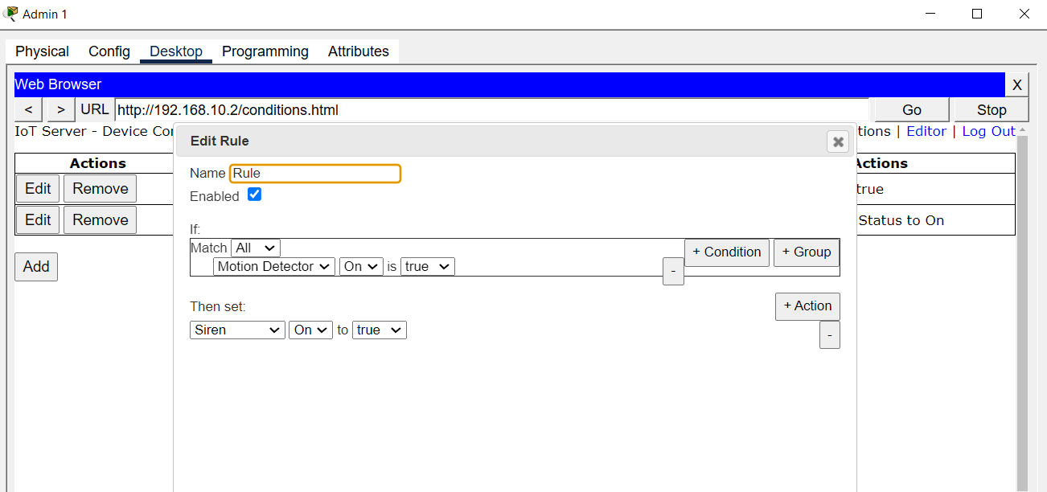

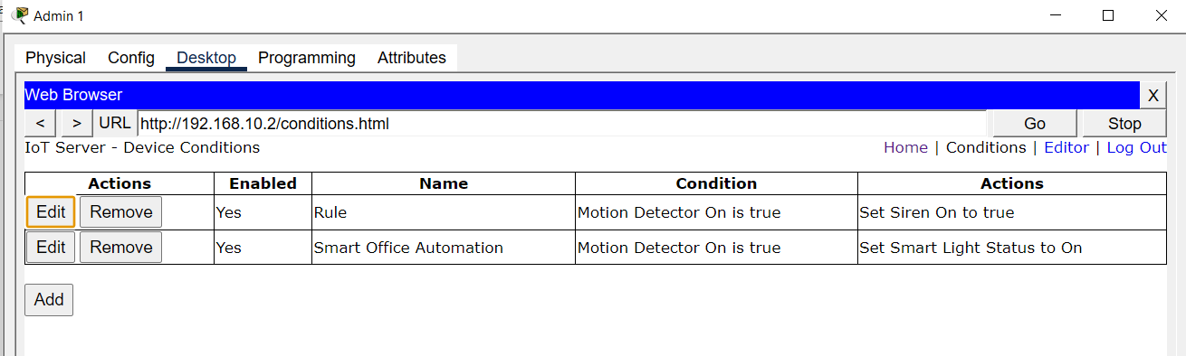
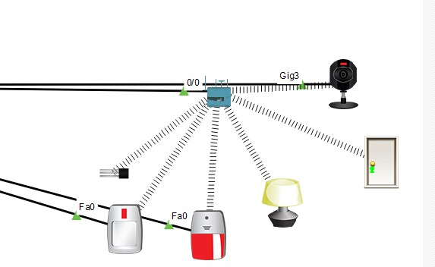

Camera
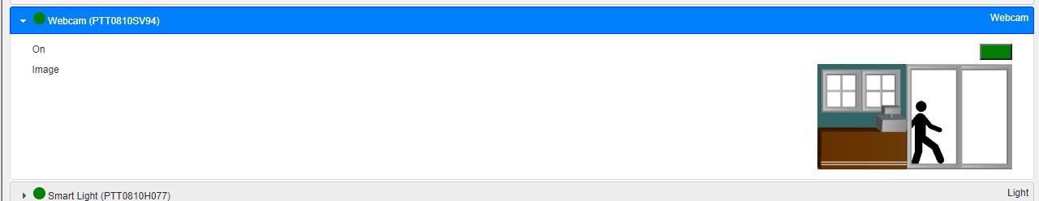
Access demonstration and monitoring for the CCTV.
9.​Connectivity test screenshots
Below are connectivity tests across IP, DNS and FTP testing.

10.​Troubleshooting performed
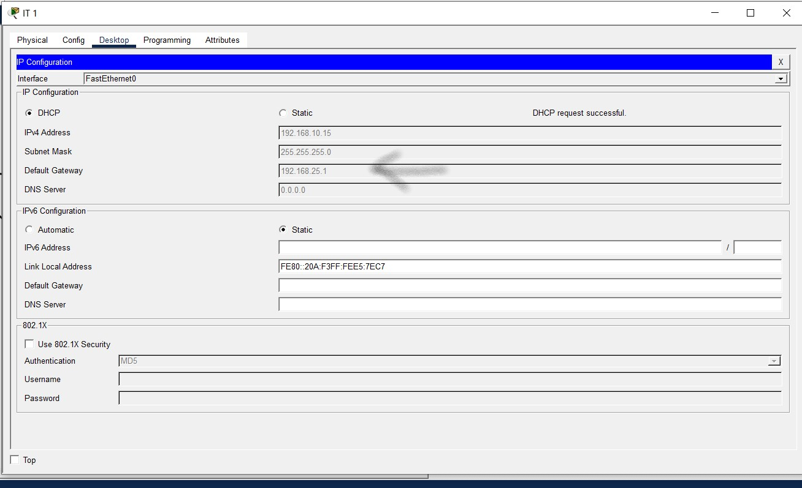
Bump into an error because an IT Laptop wireless took Home Gateway DHCP address which was rectified by turning off wireless connection on the Laptop.

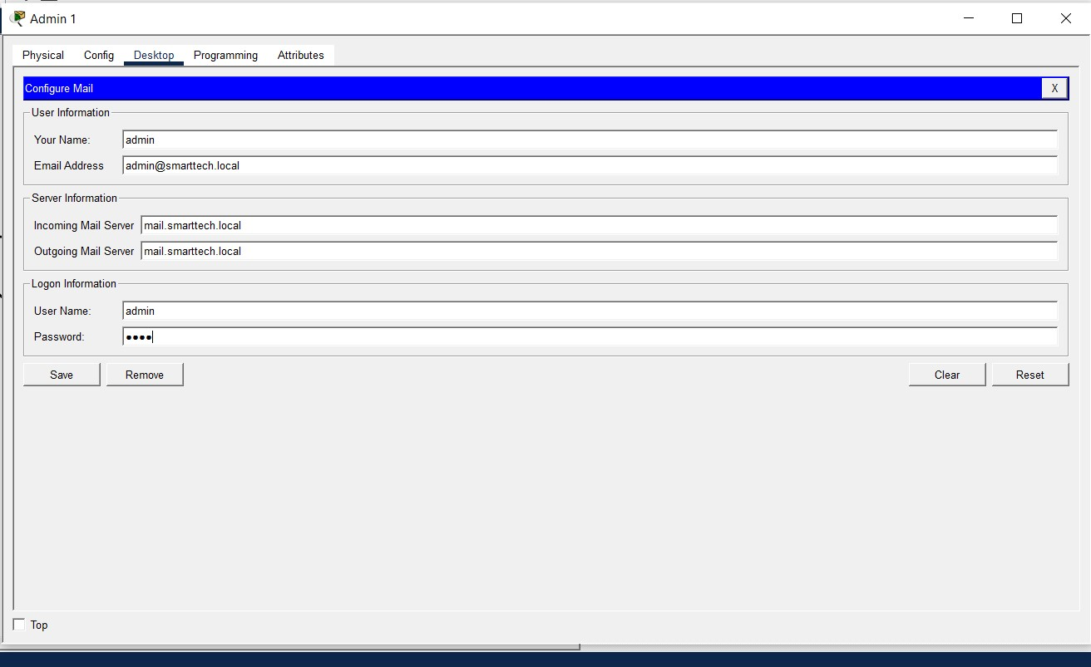
Troubleshooted mail creation because cisco keeps invalidating .local as a genuine mail address. Used .loc as the email address which only serves as the senders or receiver’s name but when trying to send a mail the address must end with .local as registered in the domain

11.​Short conclusion
This project successfully implemented a functioning network infrastructure for SmartTech, covering IP addressing, DHCP, DNS, HTTP, FTP, email, and IoT services across the Admin, IT, and Management departments. Core services were configured and verified through direct testing — ping, nslookup, and live file transfers — confirming that devices could resolve, connect to, and communicate across the network as intended. Role-based access control was applied to the FTP service to restrict employee permissions relative to administrators, and IoT devices were integrated with automation (motion-triggered lighting) and CCTV monitoring, extending the network beyond traditional data services.
Two issues arose during implementation: a wireless client inadvertently acquiring an address from the Home Gateway's DHCP pool, and Cisco's Packet Tracer rejecting .local as a valid mail domain during account creation. Both were diagnosed and resolved, reinforcing the importance of consistent DHCP scoping and awareness of simulator-specific constraints. Overall, the exercise demonstrates a working understanding of core network services and the troubleshooting skills needed to deploy them reliably.

